Weekly Report
Week 4: 2026/06/22 - 2026/06/28

The Subject of This Week:
- Provider Exclusion List Project
- The objective of this project is to create a database that contains all of the excluded providers.
- The ten states that I’m responsible for include Georgia, Hawaii, Idaho, Illinois, Indiana, Iowa, Kansas, Kentucky, Louisiana, Maine
- Tools/applications that we will use: PostgreSQL, pgAdmin 4, Python, Django, DBdiagram, Excel

Weekly status / progress:
- Combine & merge the staging tables into a large main table
- Reviewed the columns of the tables and modify those with only full names of the providers to split the “full names” into “first name”, “middle name”, and “last name”
- Use Django in Python to build the searching webpage for the database
- Modify the searching program to show key information needed in searching results, including “last name”, “first name”, “business name”, “state”. “souce”, “exclusion date”, and “NPI”
- Modify the searching system to set two searching box, one to search by name and another to search by NPI
- Modify the searching system to make sure that the searching results are sorted by relevance; when searching by name, prioritize relevance of last name, then first name, and then business name
- Modify the searching system to set that it shows at most 100 results per page
- Found some long abnormal names shown in “last name” column after searching, revise in pgadmin to solve the problem
- Refine the webpage to make it more readable and good looking
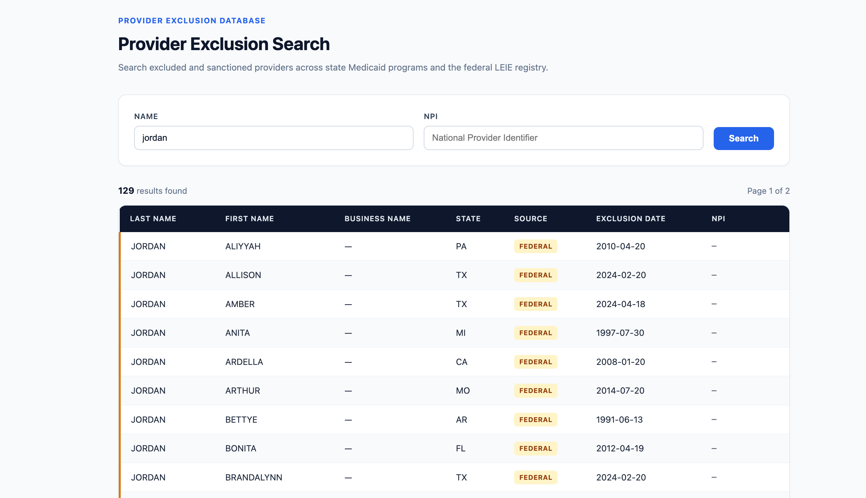

Plan for next week:
- Change the source of data to “Medicare” and “Medicaid” instead of “Federal” and “State”
- Upload all the work into Github

Hours Worked: 15h

